**WEEK 7**

**Aim:** Plot pdf and cdf of Normal distribution

**Problem Statement:**

1. Let X be a R.V follows normal distribution with mean 2.5 S.D 0.5 plot the pdf, CDF in the interval (-10,10)

2. Find the area under the curve to the left of 1 for standard normal curve. Find the area to the right of 2 for standard normal curve.

**Code:**

x=seq(-10,10,length=100)

y=dnorm(x,mean=2.5,sd=0.5)

plot(x,y,type="l")

pnorm(1,2.5,0.5)

xp2=seq(-10,1,length=60);

yp2=dnorm(xp2,2.5,0.5);

plot(x,y,type="l")

polygon(c(-10,xp2,1),c(0,yp2,0),col="pink")

text(-3,0.4,"less than 1")

1-pnorm(2,2.5,0.5)

xp3=seq(2,10,length=100)

yp3=dnorm(xp3,2.5,0.5)

plot(x,y,type="l")

polygon(c(2,xp3,10),c(0,yp3,0),col="light blue")

**Output:**

> x=seq(-10,10,length=100)

> y=dnorm(x,mean=2.5,sd=0.5)

> plot(x,y,type="l")

> pnorm(1,2.5,0.5)

[1] 0.001349898

> xp2=seq(-10,1,length=60);

> yp2=dnorm(xp2,2.5,0.5);

> plot(x,y,type="l")

> polygon(c(-10,xp2,1),c(0,yp2,0),col="pink")

> text(-3,0.4,"less than 1")

> 1-pnorm(2,2.5,0.5)

[1] 0.8413447

> xp3=seq(2,10,length=100)

> yp3=dnorm(xp3,2.5,0.5)

> plot(x,y,type="l")

> polygon(c(2,xp3,10),c(0,yp3,0),col="light blue")

Graph:

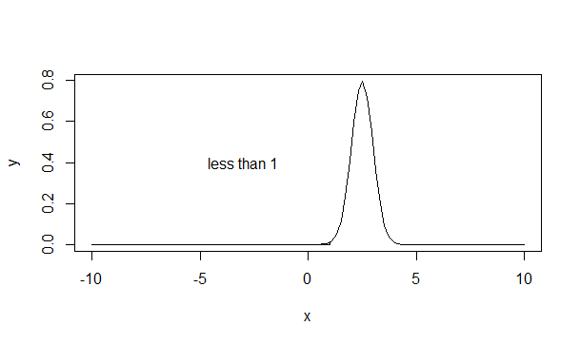

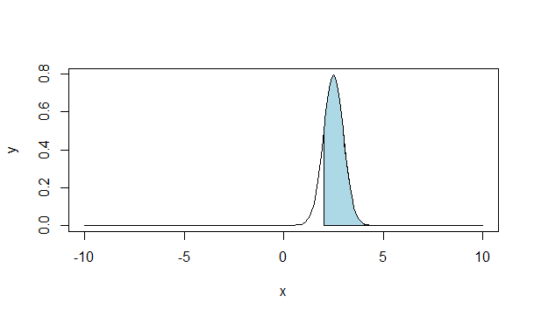

**Result:**

The PDF and the CDF for a normal distribution were successfully plotted.